### Java 分页

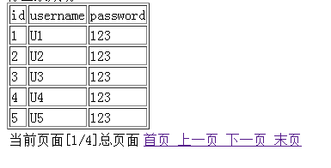

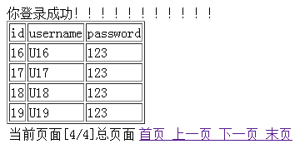

1、建Page 分页pojo：

**public** **class** Page {

**private** **int** maxResult = 5;

**private** **int** currentPage;

**private** **int** totalPage;

**private** **int** endPage;

**public** **int** getMaxResult() {

**return** maxResult;

}

**public** **int** getCurrentPage() {

**return** currentPage;

}

**public** **void** setCurrentPage(**int** currentPage) {

**this**.currentPage = currentPage;

}

**public** **int** getTotalPage() {

**return** totalPage;

}

**public** **void** setTotalPage(**int** totalResult) {

**this**.totalPage = totalResult;

}

**public** **int** getEndPage() {

**return** endPage;

}

**public** **void** setEndPage(**int** endPage) {

**this**.endPage = endPage;

}

#### 2、在用户dao中写入：

**public** **static** **int** getUserAcount(){

**int** count = 0;

Connection conn = DBUtil.*getConn*();

PreparedStatement pstmt = DBUtil.*getPstmt*(conn, "select count(*) from t_user");

ResultSet rs = **null**;

**try** {

rs = pstmt.executeQuery();

**while**(rs.next()){

count = rs.getInt(1);

}

} **catch** (SQLException e) {

// **TODO** Auto-generated catch block

e.printStackTrace();

}**finally**{

DBUtil.*getClose*(conn, pstmt, rs);

}

**return** count;

}

**public** **static** List<User> getUserAll(Page page){

List<User> users = **new** ArrayList<User>();

User user = **null**;

Connection conn = DBUtil.*getConn*();

PreparedStatement pstmt = DBUtil.*getPstmt*(conn, "select * from t_user limit ?,? ");

ResultSet rs = **null**;

page.setTotalPage(*getUserAcount*());

page.setCurrentPage(page.getCurrentPage());

page.setEndPage(page.getTotalPage()%page.getMaxResult() == 0 ? page.getTotalPage()/page.getMaxResult() : page.getTotalPage()/page.getMaxResult() +1);

**try** {

pstmt.setInt(1, (page.getCurrentPage()-1)*page.getMaxResult());

pstmt.setInt(2, page.getMaxResult());

rs = DBUtil.*getRs*(pstmt);

**while**(rs.next()){

user = **new** User();

user.setId(rs.getInt(1));

user.setUsername(rs.getString(2));

user.setPassword(rs.getString(3));

users.add(user);

}

} **catch** (SQLException e) {

// **TODO** Auto-generated catch block

e.printStackTrace();

}**finally**{

DBUtil.*getClose*(conn, pstmt, rs);

}

**return** users;

}

#### 3.servlet

**public** **void** doGet(HttpServletRequest request, HttpServletResponse response)

**throws** ServletException, IOException {

Page page = **new** Page();

page.setCurrentPage(1);

**if**(request.getParameter("currentPage") != **null**){

page.setCurrentPage(Integer.*parseInt*(request.getParameter("currentPage")));

}

List<User> users = UserSerice.*getInstance*().findUserAll(page);

request.setAttribute("users",users);

request.setAttribute("page", page);

request.getRequestDispatcher("user.jsp").forward(request, response);

}

#### 5.jsp：

<table border=*"1"* width=*"40"*>

<tr>

<td>id</td>

<td>username</td>

<td>password</td>

</tr>

<c:forEach items="${users }" var=*"user"*>

<tr><td>${user.id }</td>

<td>${user.username }</td>

<td>${user.password}</td></tr>

</c:forEach>

</table>

<table>

<tr><td>当前页面[${page.currentPage}/${page.endPage}]总页面</td>

<td><a href=*"userPage.do?currentPage=1"*>首页</a><a href=*"userPage.do?currentPage=*${page.currentPage == 1 ? 1 : page.currentPage - 1} *"*>

上一页<a href=*"userPage.do?currentPage=*${page.currentPage == page.endPage ? page.endPage : page.currentPage + 1} *"*> 下一页</a><a href=*"userPage.do?currentPage=*${page.endPage}*"*> 末页</a></td></tr></table>